**SK Record Management System**

**PHP based system**

**Created @ Sassy InfoTech**

**Version 1, 24 May, 2017**

SK ADMIN PANEL

**Introduction:**

The document shows SK admin panel screens which functions (Use cases) , the screen has been created with the intention of SK supreme admin viewing and using it. The various functions provided currently are:

1. Roles creation with permission allotment (included in **Roles and permission** tab)
2. Depositors list view and filtering (included in **Depositor** tab)
3. Create depositor and manage its associated elements (please follow link <http://demo-host.co/mumbaiall/harshal/sk/depositors-defination.php> ) (included in **Depositor** tab)
4. Sub- admin list view (included in **Sub-admin** tab)
5. Sub- admin creation (included in **Sub-admin** tab)
6. Warehouse creation and list view (included in **Warehouse** tab)
7. Order requests for delivery lists (included in **Order-** **Delivery** tab)
8. Order requests for delivery detail page (included in the **Order-** **Delivery** tab)
9. Order requests for Barcode list page (included in the **Order-**  **Barcode** tab)
10. Order requests for Barcode detail / Generation page (included in the **Order-**  **Barcode** tab)
11. Inventory list page (included in the **Order-**  **Barcode** tab)

Other features and module of SK admin will be provided once we get on with confirmation of below functionalities /use cases.

Please find below screens and details:

**Screens and Use Cases:**

1. **SK Admin Panel : Depositors**

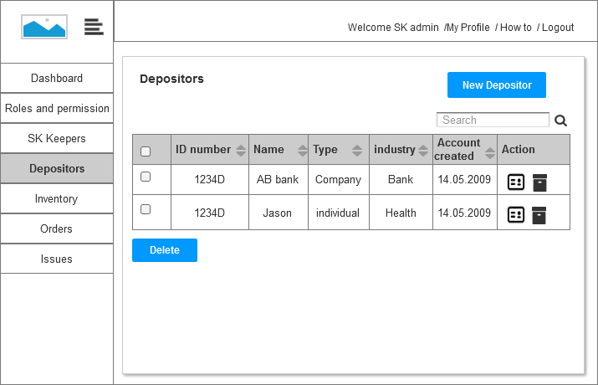

**Use cases/ Functions in this screen**

* SK admin (or Permitted SK admin) can view the list of all depositors he has created.
* SK admin (or Permitted SK admin) can search the list with name, ID, type, industry.
* SK admin (or Permitted SK admin) can view the Depositor details and
* SK admin (or Permitted SK admin) can create a new Depositor using the “New Depositor” button, this will redirect the SK admin to create a new depositor account and account details. <http://demo-host.co/mumbaiall/harshal/sk/depositors-defination.php>
* SK admin (or Permitted SK admin) can delete the Depositor records at his will.

1. **Admin panel : Roles and Permission**

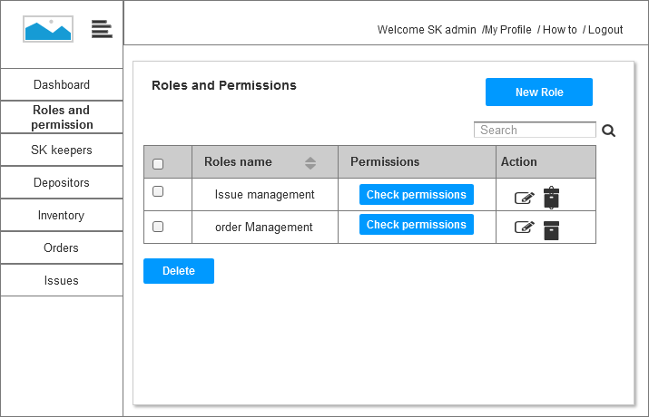

**Use cases/ Functions in the screen**

* SK admin (or permitted SK admin) can create a new role using NEW ROLE button (see screen 3).
* SK admin (or permitted SK admin) can see the list of all the roles created
* SK admin can edit the roles permission.
* These role permissions defined will be allotted to SK admins created by Supreme SK admin, See screen 6.

1. **Admin Panel : Permission allotments to new role**

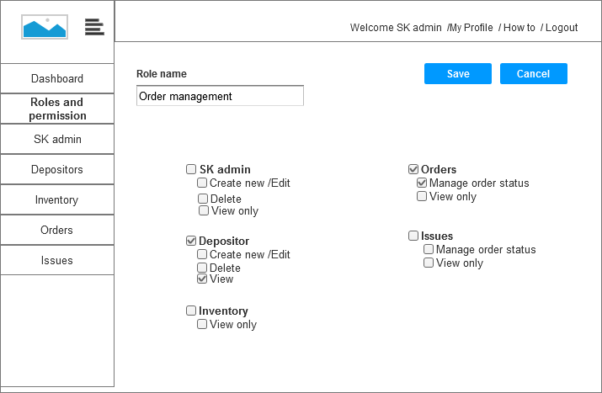

**Use cases/ Functions in the screen**

* New role is created by admin a name to it and assigning modules (depositors, orders, issues etc) to the role defined.
* Each role has check boxes which defines the actions usually used in the module. These actions can be assigned to each role defined.
* Using the roles defined, SK Supreme admin can allot roles to new SK admin created.

**5. Admin panel: sub admin lists**

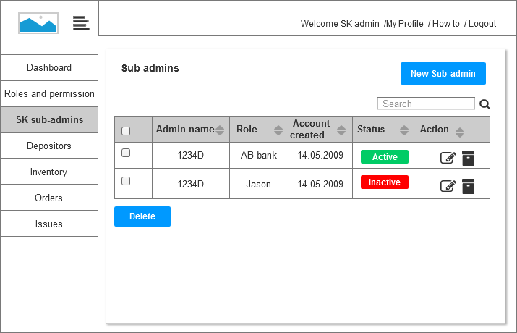

**Use cases/ Functions in the screen**

* SK supreme admin can see the list of all the SK sub-admins created
* SK admin can create a new SK sub admin using New Admin button (see screen 6 for action)
* SK admin can edit the sub- admin details using edit button, can activate and inactivate the account.
* SK admin can delete a sub-admin
* SK admin can search a sub- admin from the whole list.

**6. Sub admin create new**

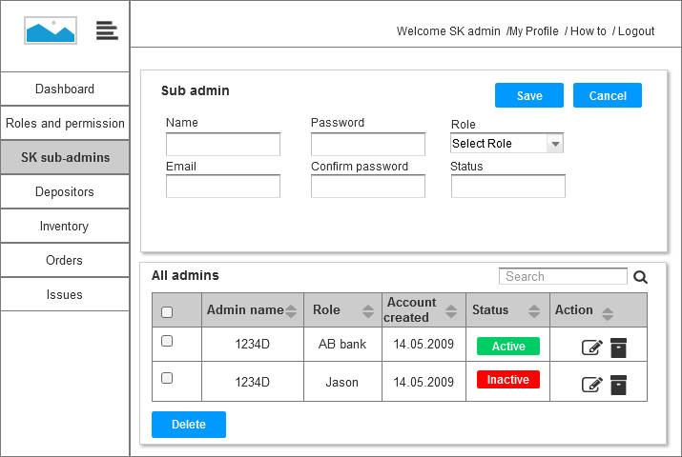

**Use cases/ Functions in the screen**

* Creating a new SK sub admin requires to fill the simple detail form with, email id, role , password, and name.
* This is the same page to edit the SK sub admin details
* The SK sub-admin will get an email for his login credentials and can view the ADMIN PANEL as per the permission provided.

**7. Admin Panel: Warehouse**

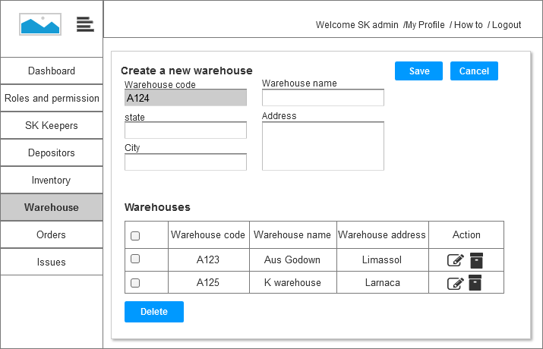

**Use cases/ Functions in the screen**

* SK admin can create a warehouse, which will be used to allot a container code to a warehouse.
* SK admin can edit the warehouse details from this page
* SK admin can see the list of warehouses in this page
* SK admin can delete a warehouse at his will.

**8. Admin panel: order for delivery**

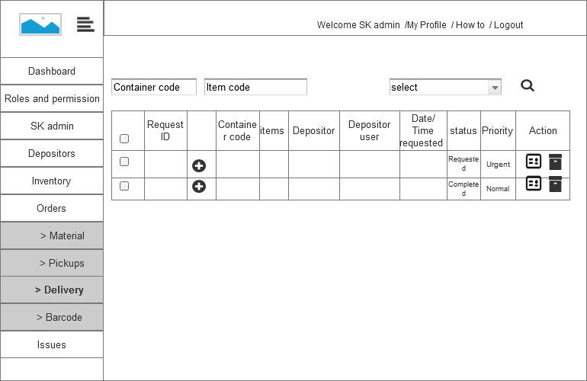

**Use cases/ Functions in the screen**

* SK admin can see the list of requests (with request ID ) , for delivery of container or folder (original or electronic or scanned copy).
* SK admin can filter the request based on urgency, container code, and item code.
* SK admin with  can see the list of folders which has been requested for the delivery.
* SK admin when executed the request will see the request status changed from (requested to complete)
* SK admin can delete the requests (only completed).
* SK admin can process the request by going into the order request page , see screen number 8

1. **Admin panel: order request for delivery detail page.**

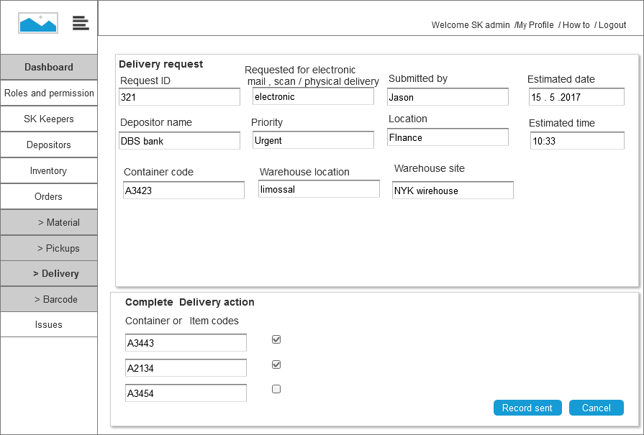

**Use cases/ Functions in the screen**

* SK admin can view the Request for delivery and will execute the request as asked.
* SK admin will view the detail screen , see the details like *type of delivery request, request submitted by* ,*request date and time* (as per service level agreement) , *Container code number* (with which request has been created ).
* Sk admin can view in which *warehouse location* and *warehouse site* , the document is present. SK admin can view the type of delivery request (electronic mail, scan post, original delivery).
* SK admin can view the item or folder codes and, will check and submit for which request has been executed. (if instead of item or folder, Container is asked for delivery then container code will appear )

**9. Admin panel: Barcode request**

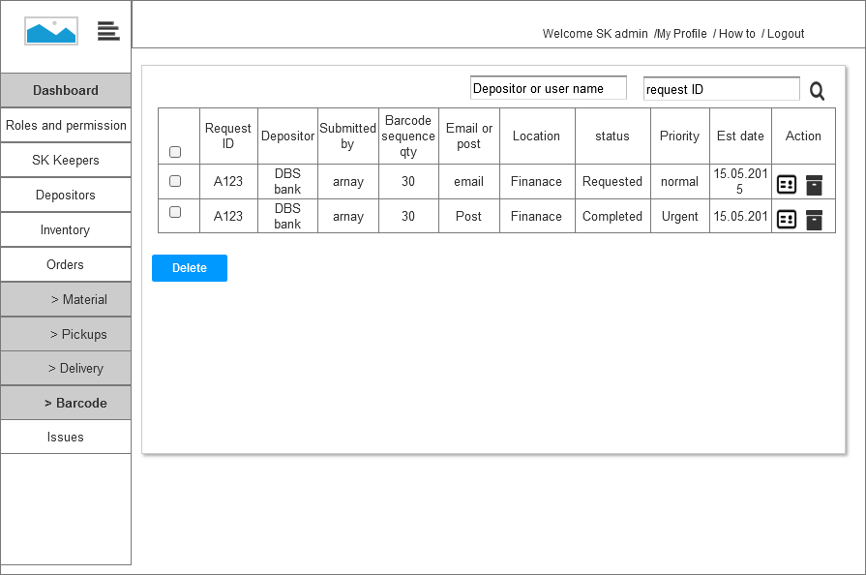

**Use cases/ Functions in the screen**

* SK admin can see the list of Barcode generation request given by the depositors.
* SK admin can view the details in detail page using  (screen number 10) , and will generate the code of depositor or depositor user.
* Sk admin can search the list using depositor name or depositor users name. Or can search by request ID.
* SK admin can delete the request for barcode label.

**10: Admin panel: barcode generation request.**

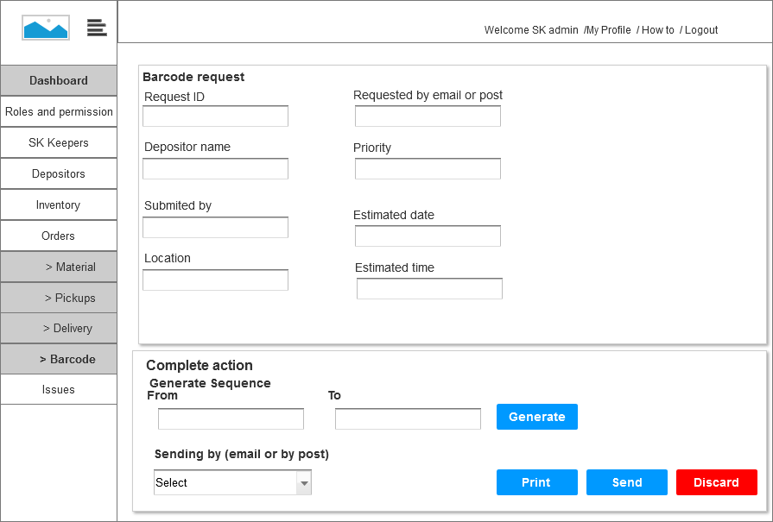

**Use cases/ Functions in the screen**

* This step helps SK admin to see the request details , with estimate time and date.SK admin also can see the request type for barcode(email or post)
* SK admin can create the Barcode, giving the barcode sequence start to end number .
* The barcode start to end number will check if any barcode number is duplicate or not in the database record. If duplicate then barcode will not be generated.
* If barcode numbers are not duplicate then, barcode will be successfully generated . (message will appear for the same)
* SK admin can then print the barcode created, or can put the status of Barcode sent, ( a email to user will be sent)
* SK admin can discard the barcode created, if not emailed to user. Discarding will destroy the barcode number created. But if emailed, the barcode cannot be discarded.

**11. Admin panel: inventory list**

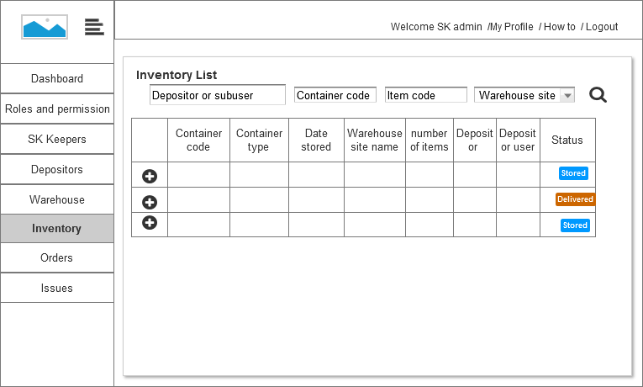

**Use cases/ Functions in the screen**

* SK admin can see the list of inventory he has in his different warehouses, the inventory are in boxes and each box can consists of items /folders.
* Using this icon  , user can extend the container details and see the items/folder list (each folder has item code assigned using barcode).
* The status of each container (stored or delivered ) will be visible in the table
* SK admin cannot edit the container details and item details, this right has only be given to depositors and depositors user.
* SK admin can filter and sort the table using (depositor name , container code , item code, or by selecting warehouse)